Check for firewalld

sudo systemctl enable firewalld.service

Drop all connections while removing users and reopen what's needed later

Initial users

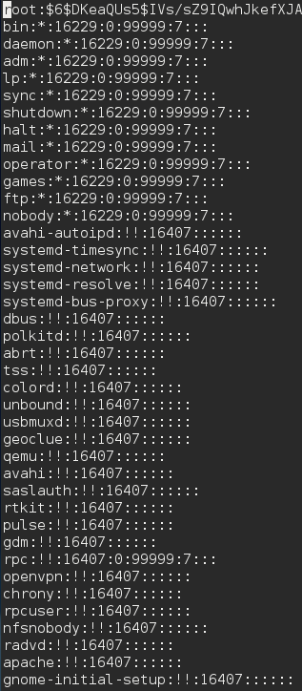

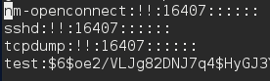

Remove nullok from /etc/pam.d/system-auth

Make sure there is only one UID 0

Make sure that is no vc/*, ttys* in the sudo echo > /etc/securetty File

Change /etc/pam.d/postlogin To say

session [success=1 default=ignore] pam_succeed_if.so service !~ gdm* service !~ su* quiet

session [default=1] pam_lastlog.so nowtmp showfailed

session optional pam_lastlog.so silent noupdate showfailed

Check echo $PATH if ‘.’ is in it there’s a problem

Save -a always,exit -F arch=b64 -S fchown -F auid>=1000 -F auid!=unset -F key=perm_mod

to /etc/audit/audit.rules

Sets arch to b32 if 32 bit

INSTALL DOCKER

Check to make sure there are no world or group writeable files

Mail Server:

Check /etc/dovecot/conf.d/10-auth.conf

SMTP auth

Nano /etc/dovecot/conf.d/10-master.conf

Comment out

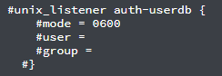

Edit

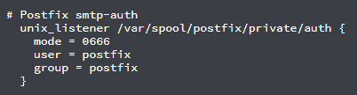

POP3

Nano /etc/dovecot/conf.d/20-pop3.conf

Add/uncomment

